Amplicon similarity search med blastn:

Ggtggtttctggggtgacagggttgattctcagcccttcgccctcccctatattcatccaaccaacccct

|  |  |
| --- | --- |
| **Search Parameters** | |
|  |  |
| Program | blastn |
| Word size | 11 |
| Expect value | 10 |
| Hitlist size | 100 |
| Match/Mismatch scores | 2,-3 |
| Gapcosts | 5,2 |
| Low Complexity Filter | Yes |
| Filter string | L;m; |
| Genetic Code | 1 |

|  |  |
| --- | --- |
| **Database** | |
|  |  |
| Posted date | Aug 6, 2020 4:47 PM |
| Number of letters | 315,026,240,624 |
| Number of sequences | 59,991,124 |
| Entrez query | Excludes: Orthohepevirus A (taxid:1678143) |

|  |  |  |
| --- | --- | --- |
| **Karlin-Altschul statistics** | | |
|  |  |  |
| Lambda | 0.633731 | 0.625 |
| K | 0.408146 | 0.41 |
| H | 0.912438 | 0.78 |

|  |  |
| --- | --- |
| **Results Statistics** | |
|  |  |
| Length adjustment | 35 |
| Effective length of query | 35 |
| Effective length of database | 312926551284 |
| Effective search space | 10952429294940 |
| Effective search space used | 10952429294940 |

Hittade inget oroväckande.

Mfold analysis of secondary structures for DNA and RNA

<http://unafold.rna.albany.edu/?q=mfold>

  DNA folding of 20Aug14-09-32-09 at 55°

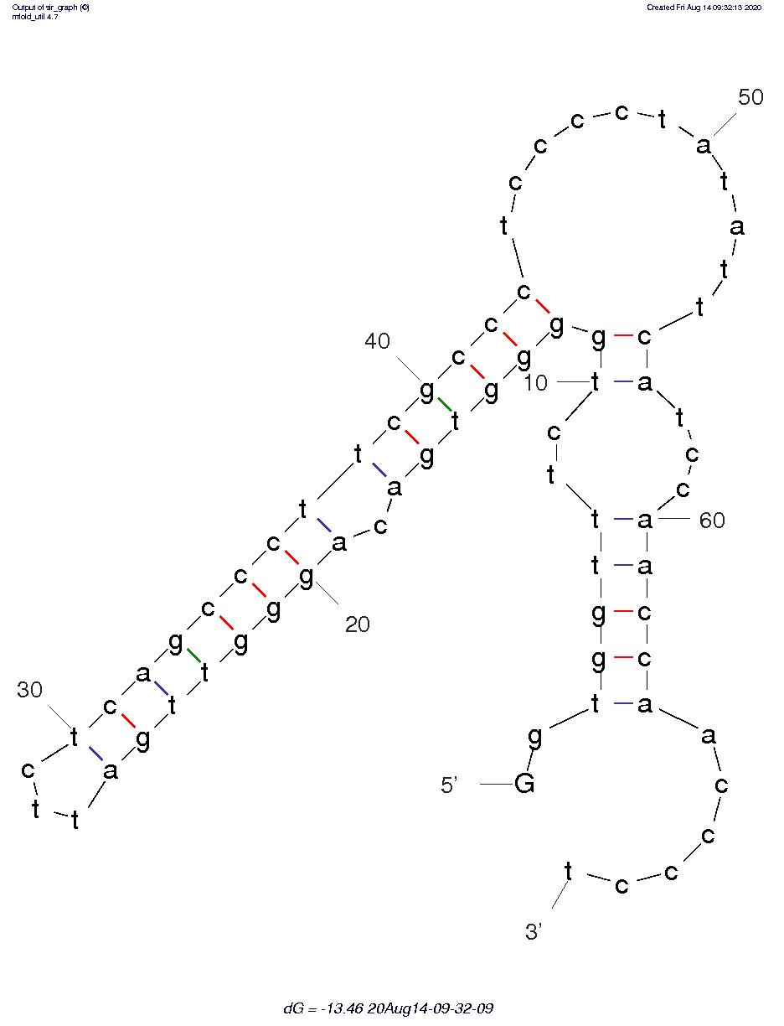

RNA

**20Aug14-09-35-56 at 37° C.**

